

**Semester Two Examination 2019**

**Question/Answer Booklet**

**PHYSICAL EDUCATION**

**STUDIES UNITS 1 & 2**

Student Name: _____________________________________

Teacher’s Name: _____________________________________

Time allowed for this paper

Reading time before commencing work: Ten minutes

Working time: Two and a half hours

**Materials required/recommended for this paper**

***To be provided by the supervisor***

This Question/Answer booklet

Multiple-choice answer sheet

***To be provided by the candidate***

Standard items: pens (blue/black preferred), pencils (including coloured), sharpener,

correction fluid/tape, eraser, ruler, highlighters

Special Items: non-programmable calculators approved for use in this examination

Important note to candidates

No other items may be taken into the examination room. It is your responsibility to ensure that you do not have any unauthorised material. If you have any unauthorised material with you, hand it to the supervisor before reading any further.

**Structure of this paper**

|  |  |  |  |  |  |
| --- | --- | --- | --- | --- | --- |
| Section | Number of questions available | Number of questions to be answered | Suggested working time  (minutes) | Marks available | Percentage of written examination |
| Section One  Multiple-choice | 20 | 20 | 30 | 20 | 20 |
| Section Two  Short answer | 8 | 8 | 70 | 50 | 50 |
| Section Three  Extended answer | 4 | 2 | 50 | 30 | 30 |

100

**Total**

# Instructions to candidates

1. The rules for the conduct of this exam have been outlined. Sitting this examination implies that you agree to abide by these rules.
2. Write your answers in the Question/Answer booklet preferably using a blue/black pen. Do not use erasable or gel pens.
3. Answer all questions according to the following instructions.

Section One: Answer **all** questions on the separate Multiple-choice Answer Sheet provided. For each question shade the box to indicate your answer. Use only a blue or black pen to shade the boxes. If you make a mistake, place a cross through that square, then shade your new answer. Do not erase or use correction fluid/tape. Marks will not be deducted for incorrect answers. No mark will be given if more than one answer is completed for any reason.

Section Two: Write answers to in this Question/Answer Booklet. Wherever possible, confine your answers to the line spaces provided

Section Three: Consists of four questions. You must answer two questions. Write

your answers in this Question/Answer booklet.

1. You must be careful to confine your responses to the specific questions asked and to follow any instructions that are specific to a particular question.
2. Supplementary pages for planning/continuing your answers to questions are provided at the end of this Question/Answer booklet. If you use these pages to continue an answer, indicate at the original answer where the answer is continued, i.e. give the page number.

**Section One: Multiple Choice 20% (20 marks)**

This section has **twenty (20)** questions. Answer **all** questions on the separate Multiple-choice answer sheet provided. For each question, shade the box to indicate your answer. Use only a blue or black pen to shade the boxes. If you make a mistake, place a cross through that square, then shade your new answer. Do not erase or use correction fluid/tape. Marks will not be deducted for incorrect answers. No marks will be given if more than one answer is completed for any question.

Suggested working time: 30 minutes.

1. During the backswing phase of a football kick, the leg is drawn behind the body prior to the forward swing of the leg. When the leg is drawn behind the body, which of the following movements occurs at the hip joint?

(a) flexion

(b) extension

(c) abduction

(d) adduction

2. A tennis player who creates a visual representation of themselves extending at the

elbow just prior to serving is an example of imagery and

1. stress.
2. self-confidence.
3. arousal.
4. concentration.

3. In an 800m running race, the finish line (when starting in lane 1) is also the start line. What does 800m represent?

(a) velocity

(b) distance

(c) displacement

(d) angular displacement

4. An athlete underwent an extensive period of anaerobic training. During this period, they ran varying distances no longer than 400m and typically at a very high intensity. Which of the following chronic adaptations would be least likely to occur?

(a) an increase in the number and size of mitochondria

(b) an increase in glycolytic enzymes

(c) an increase in ATP-PC stores

(d) an increased tolerance of lactic acid

5. Whilst playing in the French Open tennis final, Rafael Nadal sees his shot hit the line, causing a puff of white powder to appear from the line marking. What source of feedback is Rafael receiving in this instance?

(a) concurrent

(b) internal

(c) external intrinsic

(d) external augmented

6. A muscle directly involved in causing a segment to move is called the

(a) agonist

(b) antagonist

(c) stabiliser

(d) controller

7. The following table represents a training day for a 3000m runner.

|  |  |  |  |  |
| --- | --- | --- | --- | --- |
| **Set** | **Reps** | **Distance** | **Time to complete repetition** | **Rest (between reps)** |
| 1 | 6 | 400m | 75 seconds | 90 seconds; jog/walk |
| 2 | 6 | 600m | 120 seconds | 150 seconds; jog/walk |

What type of training method is the athlete using?

(a) continuous

(b) fartlek

(c) interval

(d) plyometrics

8. The image below shows a golf driving range with 3 different levels. If the same golfer hit the same drive, with the same golf club, from each of the different heights, which of the following statements would be true? The shot would travel the

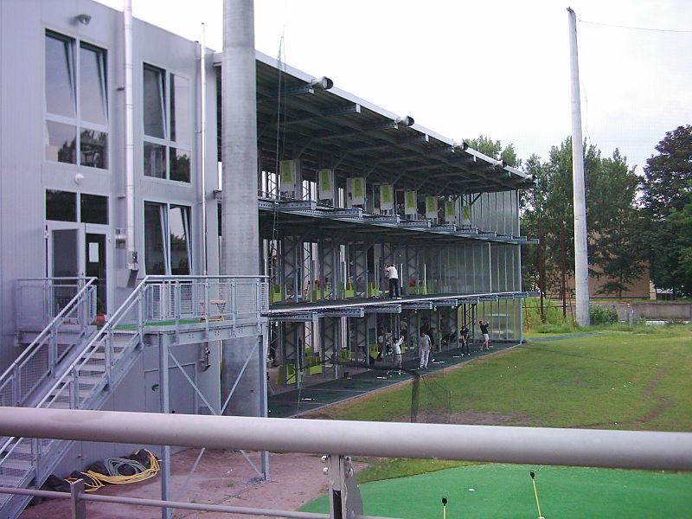

(a) furthest from the bottom level

(b) furthest from the middle level

(c) furthest from the upper level

(d) same distance irrespective of level

9. According to Nideffer’s Model of Attentional control, which of the following athletes would be described as ‘internal and narrow’?

1. Tour de France rider
2. rugby player
3. netballer
4. golfer

10. The type of activity an athlete participates in is likely to affect the optimal arousal level required for optimum performance. Which of the following is likely to represent the different arousal curves in the diagram below:

**2**

**1**

**4**

**3**

**Performance**

**Arousal**

(a) 1 – archery, 2 – blocking in football, 3 – penalty kick in soccer, 4 – volleyball spike

(b) 1 – archery, 2 – volleyball spike, 3 – penalty kick in soccer, 4 – blocking in football

(c) 1 – blocking in football, 2 – volleyball spike, 3 – penalty kick in soccer, 4 – archery

(d) 1 – archery, 2 – penalty kick in soccer, 3 – volleyball spike, 4 – blocking in football

11. In preparation for an upcoming event, two athletes engage in a 2km training run and both run at the same speed. Athlete A has just started training and is considered relatively unfit whilst Athlete B has been training for months and is reaching peak condition. At the 1km point of the run, which of the following statements is most likely to be correct?

(a) The cardiac output of Athlete A is likely to be significantly higher than Athlete B.

(b) Athlete A would have a lower heart rate than Athlete B due to a higher stroke volume.

(c) Athlete B would have a lower heart rate than Athlete B due to a higher stroke volume.

(d) The cardiac output of Athlete B is likely to be significantly higher than Athlete A.

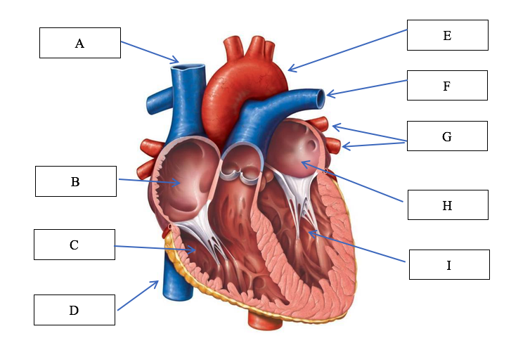12. Which of the following options correctly identifies the structures of the heart?

(a) A: Vena cava, B: right atrium, C: right ventricle, E: aorta, F: pulmonary vein: left atrium, G: pulmonary artery

(b) A: Vena cava, B: right atrium, C: right ventricle, E: aorta, F: pulmonary artery,

G: pulmonary vein

(c) B: left atrium, C: left ventricle, D: vena cava, E: aorta, H: right atrium, I: right ventricle

(d) B: left ventricle, C: left atrium, D: vena cava, E: aorta, H: right ventricle, I: right atrium

13. An athlete who listens to high tempo music and uses positive self-talk prior to a performance is most likely trying to regulate

(a) self-confidence

(b) concentration

(c) arousal

(d) stress and anxiety

14. The day after a failed attempt at the Red Bull Cliff Diving, an athlete is told by her coach that she needed to get into her tuck earlier to allow for full extension prior to hitting the water. This feedback is

(a) external augmented, knowledge of performance, terminal.

(b) external augmented, knowledge of performance, concurrent.

(c) external intrinsic, knowledge of performance, terminal.

(d) external augmented, knowledge of result, concurrent.

15. During a 400m running sprint, there is a transition period in which the Anaerobic Glycolysis system takes over from the ATP-PC system as the dominant provider of ATP. This typically occurs after approximately

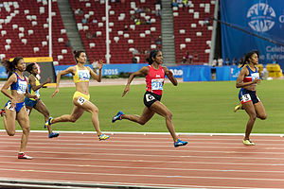

(a) 1-5 sec

(b) 5-10 sec

(c) 20-30 sec

(d) 30-40 sec

16. If velocity is constant, then acceleration must be

(a) increasing.

(b) decreasing.

(c) zero.

(d) none of the above.

17. The following table represents a phase of a resistance training program for an elite rugby player.

|  |  |  |  |
| --- | --- | --- | --- |
| **Weight** | **Sets** | **Reps** | **Rest (between sets)** |
| 90% 1RM | 3 | 4-6 | 3 minutes |

Which fitness component does this phase of the training program specifically target?

(a) aerobic power

(b) muscular endurance

(c) muscular strength

(d) muscular power

18. Within Fitts and Posner’s Model of learning, which stage is associated with the highest requirement for thought processing in relation to performing a task?

(a) cognitive stage

(b) association stage

(c) autonomous stage

(d) associate stage

19. A professional athlete is competing in an Olympic Weightlifting competition. She has five minutes before her final lift and needs to register a personal best to win the gold. To ensure optimal arousal levels, what wouldn’t you recommend she do?

1. use relaxation techniques such as meditation to reduce arousal levels
2. use imagery to recreate a past successful performance and increase arousal levels
3. use the same pre performance routine she has used in all her previous attempts

(d) use positive self-talk to increase arousal levels

20. A penalty kick in soccer is a skill considered to be

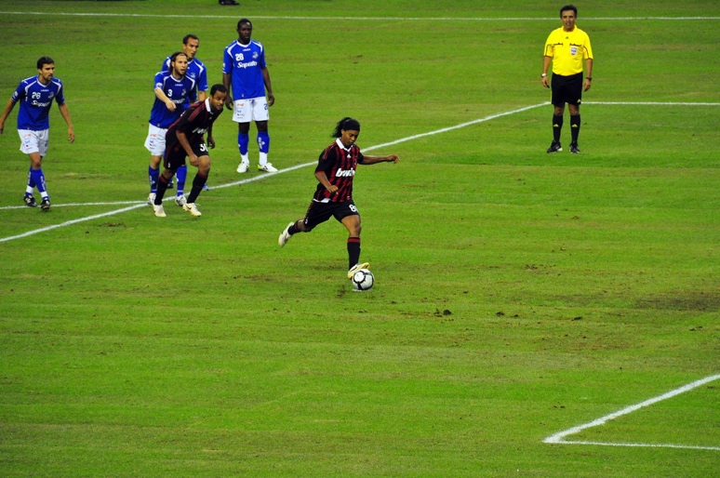

(a) open, gross and discrete.

(b) closed, fine and discrete.

(c) open, fine and discrete.

(d) closed, gross and discrete.

**End of Section One**

**Section Two: Short answer 50% (50 marks)**

This section has **eight (8)** questions. Answer **all** questions. Write your answers in the spaces provided. Use a blue or black pen (**not** pencil) for this section.

Supplementary pages for the use of planning/continuing your answer to a question have been provided at the end of this Question/Answer booklet. If you use these pages to continue an answer, indicate at the original answer where the answer is continued, i.e. give the page number.

Suggested working time: 70 minutes.

**Question 21 (7 marks)**

The following questions relate to Helen who is a 45 year old healthcare worker. She has recently started a new gym program as she is wanting to improve her muscular strength and bone density.

The image shows Helen completing a squat as part of her new gym program.

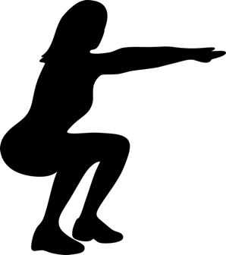

(a) When completing a squat, there are two (2) obvious joint actions occurring in the legs. Identify the joint action occurring at Helen's knee and hip during the upwards phase of the squat.

(2 marks)

(b) Identify the major muscle group allowing for the movement at the knee joint to occur.

(1 mark)

(c) Protection of vital organs is one function of the skeletal system. Identify two (2) other functions of the skeletal system.

(2 marks)

(d) From a skeletal point of view, describe how the forearm and lower leg structures are similar.

(2 marks)

**Question 22 (4 marks)**

The following question relates to the image below of a volleyball player performing a jump serve.

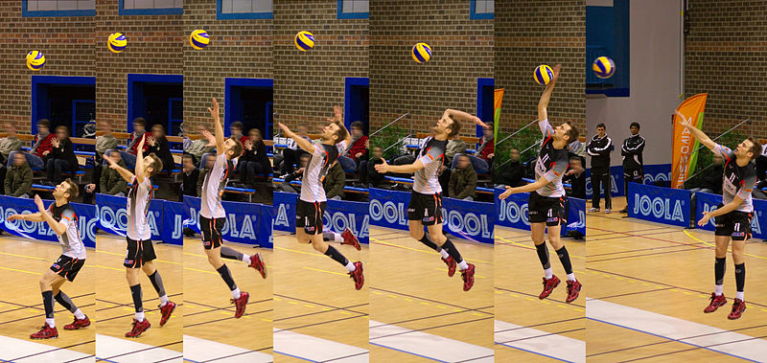

(a) Is this a gross or fine motor skill? Justify your response.

(2 marks)

(b) Is this a closed or open skill? Justify your response.

(2 marks)

**Question 23 (6 marks)**

The following graph displays data for two (2) athletes practicing their goal kicking in AFL.

(a) Using the data from the graph, identify which athlete was most likely to be in the

cognitive stage of learning. Justify your response.

(3 marks)

(b) Using the data from the graph, identify which stage of learning the other athlete

was most likely to be in. Justify your response.

(3 marks)

**Question 24 (7 marks)**

The following image shows a gymnast performing a routine on a balance beam.

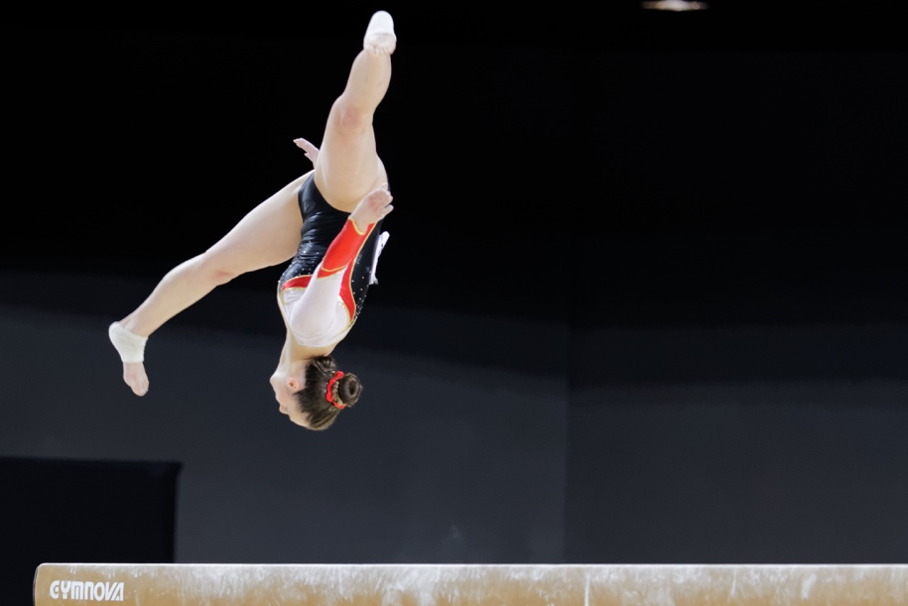

(a) Identify three (3) strategies the gymnast could use to improve her stability when she

lands on the beam after performing the pictured movement.

(3 marks)

(b) To complete her routine, the gymnast is required to move up and down the beam

performing a series of movements to impress the judges. Discuss the difference

between the distance and displacement travelled by the gymnast throughout her

routine. Use examples to support your response.

(4 marks)

**Question 25 (5 marks)**

The following graph shows the varying contributions of fats and carbohydrates during submaximal exercise.

(a) At what point does the athlete make the switch to fats as the dominant fuel supply?

(1 mark)

(b) Explain the impact this is likely to have on their performance.

(2 marks)

(c) Outline two (2) nutritional strategies the athlete could use to delay the switching to

fats as the predominant fuel source.

(2 marks)

**Question 26 (10 marks)**

The following graph shows the relative contributions of the different energy systems during a four (4) minute maximal intensity exercise bout.

(a) At what point does the anaerobic glycolysis system become the dominant energy

provider?

(1 mark)

(b) Explain why there is a delay before the aerobic energy system becomes the

dominant provider. How does the body cater for this?

(3 marks)

(c) At the 60sec mark, identify the fuel providing most energy for ATP production.

(1 mark)

(d) Discuss the concept of energy system interplay as it relates to the event in the graph

above.

(5 marks)

**Question 27 (4 marks)**

Davis Cup Tennis is a unique competition where players represent their country in a team event. Coaches and team mates sit on the sidelines and are permitted to provide feedback throughout the matches.

(a) Discuss the purpose of feedback in sport.

(2 marks)

(b) Name and provide examples of two (2) types of feedback that players would rely on

in a Davis Cup match to improve their performance.

(2 marks)

**Question 28 (7 marks)**

Earlier this year, West Coast Eagles youngster Josh Rotham made his debut against Collingwood in front of over 61000 people at the MCG.

(a) Draw a graph to represent the inverted U hypothesis and identify where Josh is likely

to appear on the curve.

(3 marks)

(b) Identify and describe two (2) strategies Josh might have used during his debut to

help manage his arousal levels.

(4 marks)

**End of Section Two**

**Section Three: Extended answers 30% (30 marks)**

This section contains **four (4)** questions. You must answer **two (2)** questions. Write your answer in the spaces provided.

Supplementary pages for the use of planning/continuing your answer to a question have been provided at the end of this Question/Answer booklet. If you use these pages to continue an answer, indicate at the original answer where the answer is continued, i.e. give the page number.

Suggested working time: 50 minutes.

**Question 29 (15 marks)**

The following question relates to the images below.

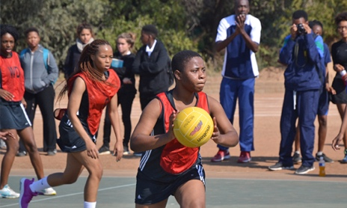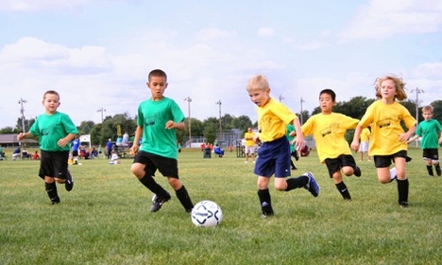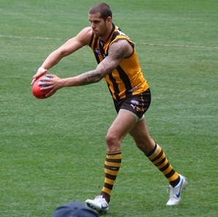

U/14’s youth netball

U/6 beginners’ soccer

Professional AFL player

(a) Identify and describe which stage of learning each of the pictured athletes are

most likely in.

(9 marks)

(b) The demands of a netball goal shot and AFL kick for distance vary greatly. Using the

biomechanical principles of segmental interaction and projectile motion, discuss the

differences between these two activities.

(6 marks)

**Question 30 (15 marks)**

In 2003 at the US Open semi-final, Justine Henin-Hardine completed what is widely recognised as the greatest comeback in female tennis history. After being down 1 set to 0 and 5-3 in the 2nd set, Henin-Hardine managed to save two match points and send it to a 3rd and final set. Again, despite being down 5-2 in the 3rd set, she managed to somehow recover, winning 7-6 to clinch a spot in the final.

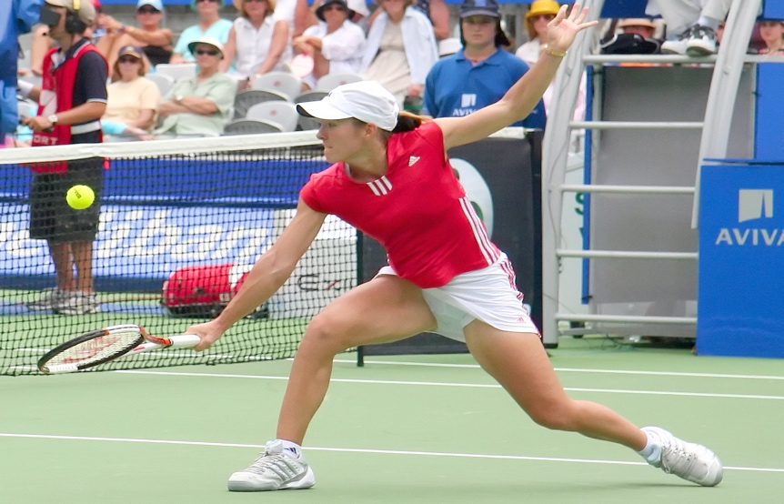

(a) Discuss three (3) mental skill strategies Henin-Hardine could have used to maintain

her self-confidence throughout the match.

(9 marks)

(b) Tennis tournaments such as the US Open require players to compete every second

day, potentially spending up to three hours on court each time they play. This places

huge stress on the body and requires elite physical preparation and optimal nutrition

practices if they want to be successful.

Outline a nutritional plan Justine could have used during and after each match to

help cope with the demands of the tournament.

(6 marks)

**Question 31 (15 marks)**

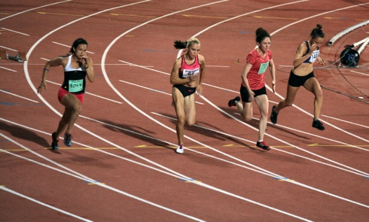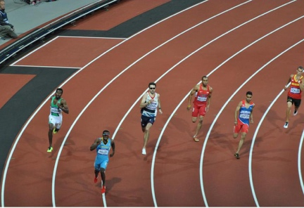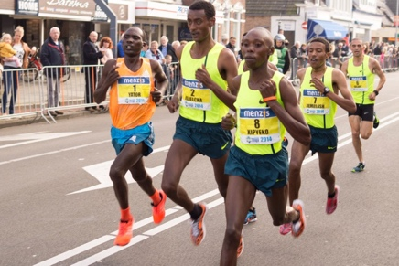

400m sprinter

Marathon runner

100m sprinter

(a) Using the three (3) athletes pictured above, discuss how the muscle fibre types

would vary for each athlete. In your answer, state each muscle fibre, include the

muscle fibre ratio of each picture and identify two (2) characteristics of each

muscle fibre type that would enable them to perform in their chosen event.

(9 marks)

(b) Discuss how each of Newton’s three (3) Laws relate to the 100m sprint.

(6 marks)

**Question 32 (15 marks)**

Two athletes set themselves the goal of competing in the London Marathon in June 2020. Athlete A is considered a trained athlete, having competed in marathons previously and regularly trains. Athlete B is considered untrained, having never run a marathon before and currently lives a relatively sedentary lifestyle.

(a) Compare the maximal cardiac output, resting heart rate and maximal stroke

volumes of Athlete A and B prior to starting their new training regimes. Furthermore

discuss two methods of training Athlete B could use to improve these dimensions.

(7 marks)

(b) Identify and outline four (4) long term respiratory adaptations Athlete B is likely to

receive as a result of a six month aerobic training program.

(8 marks)

**End of Section Three**

Supplementary page

Question number:___________

Supplementary page

Question number:___________